11776 3rd Street SE
Cooperstown, ND 58425
Phone: 701-581-6921
mail@cbcnd.com
www.cbcnd.com

Women’s Retreat Welcome Letter

IMPORTANT INFORMATION:
We’re excited you will be joining us for the Women’s Retreat. We anticipate wonderful things God has planned at CBC! Please review the following important information you will need to know.

PAYMENT DETAILS:
If you have a balance, you can pay by logging into your account at
www.ultracamp.com.
Or pay by mailing a check (with notation) to:
Cooperstown Bible Camp
11776 3rd Street SE
Cooperstown, ND 58425
You can also complete payments at arrival Friday evening registration.

REGISTRATION:
Check-in for all registered attendants begins Friday at 7pm. Registration will take place at the Lodge. Signs and volunteers will be available to help direct you if location is changed.

DONATIONS:
Donations are welcome! All donations will go towards the next CBC planned project. That will be revealed during the first main session of Women’s Retreat.

Every Women’s Retreat, we host an annual silent auction for attendees to bring new or gently used items to be auctioned off. Everyone will be able to shop and bid for items of their choice and take them home. Again, all proceeds go to the next CBC planned project.

CAMP STORE (C³):
Attendees can purchase a variety of refreshments and items at the CBC camp store such as candy, water, pop, ice cream, espresso drinks, Italian sodas, CBC apparel and gifts and more! You will find the store hours included in your retreat itinerary given to you upon arrival.

Depending on the guest speaker or worship, items such as books, cd’s, and other merchandise may be available for purchase at the guest table or in the camp store.

WHAT TO BRING:
Clothes, comfortable shoes (closed toed shoes for rock wall or high ropes), sheets, blanket, pillow, toiletries, towel, Bible, notebook, and pen.

CANCELLATION POLICY:
In the event of a medical emergency where you will not be able to attend his/her camp, registration fees will be refunded, except for a $30 non-refundable registration fee. For non-emergency reasons, refunds will be given up to 14 days prior, except for a $30 non-refundable registration fee.

QUESTIONS:
If you have any questions call or e-mail us at:
- 701-581-6921
- mail@cbcnd.com
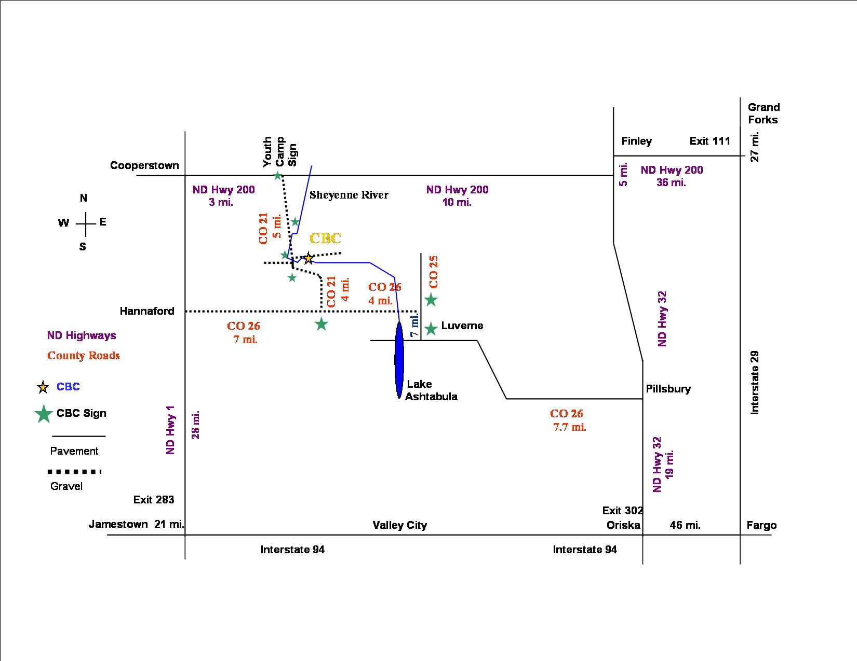
DIRECTIONS TO CAMP:

